Introduction:

Seattle has always been a desirable city. Siyuan Liu is a young artist who plans to move to Seattle and open her first personal art exhibition there. I plan to use a data-driven method to analyze the cultural space resources of each block and neighbor in Seattle to present a recommendation to Siyuan. Through that process, I also hope can help other artists who faced the similar problem of moving to a new city.

Data:

Cultural Space Inventory data from government website: <https://data.seattle.gov/>

Geocoder Seattle location data

Seattle location data from FourSquare API, including venue ID, venue Name, Latitude and Longitude, and category name.

Methodology:

• Data Cleanup and re-grouping: retrieved data, clean up unwanted data, drop uncompleted and missing data, check data type, fix if needed, and add geographical coordinates.

• Top Neighborhood Cultural Space Inventory Counts.

• Use seaborn and matplotlib.pyplot to generate graph.

• Top 10 most common Cultural Space Inventory type counts.

• Using Geocoder Seattle to retrieve coordinate data and render map with folium.

Data Cleanup: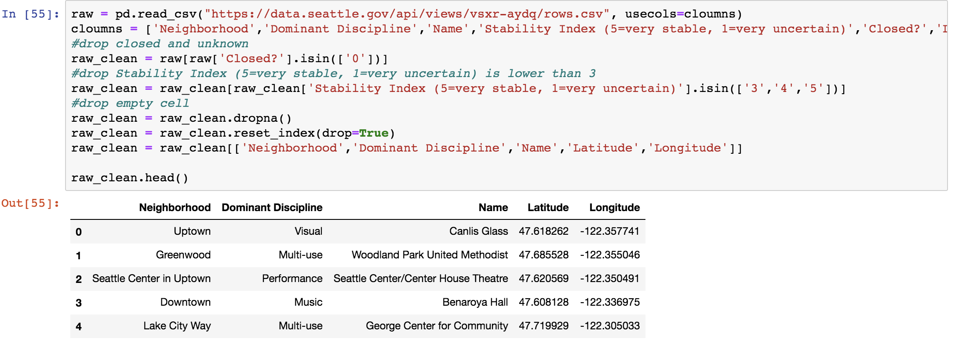

Regrouping:

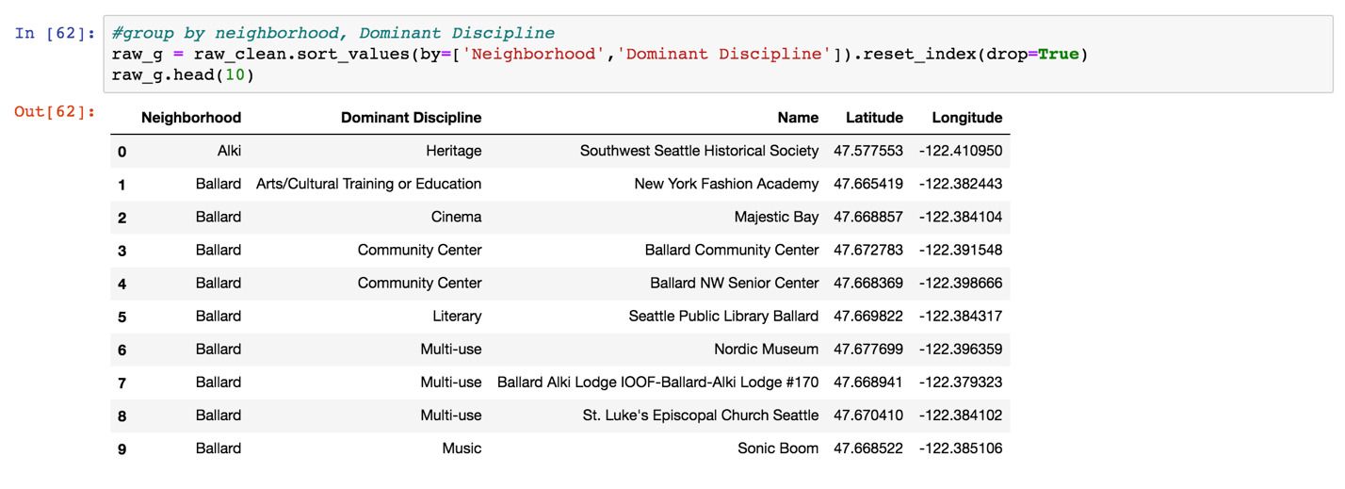

Check Counts:



Results of Check Counts:

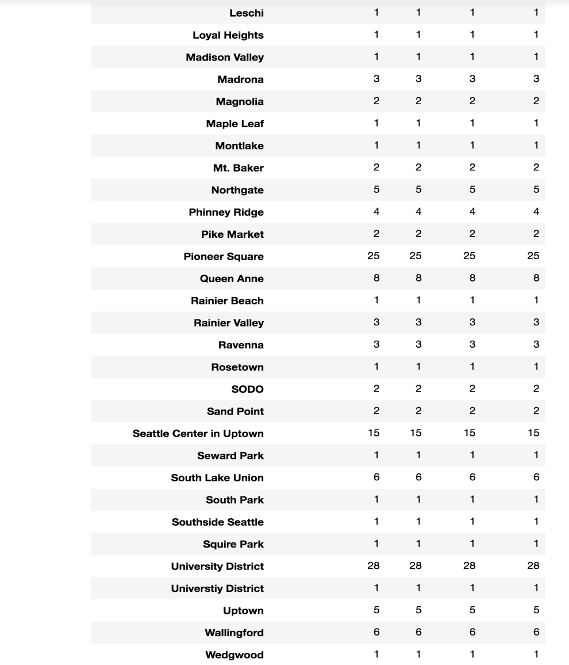

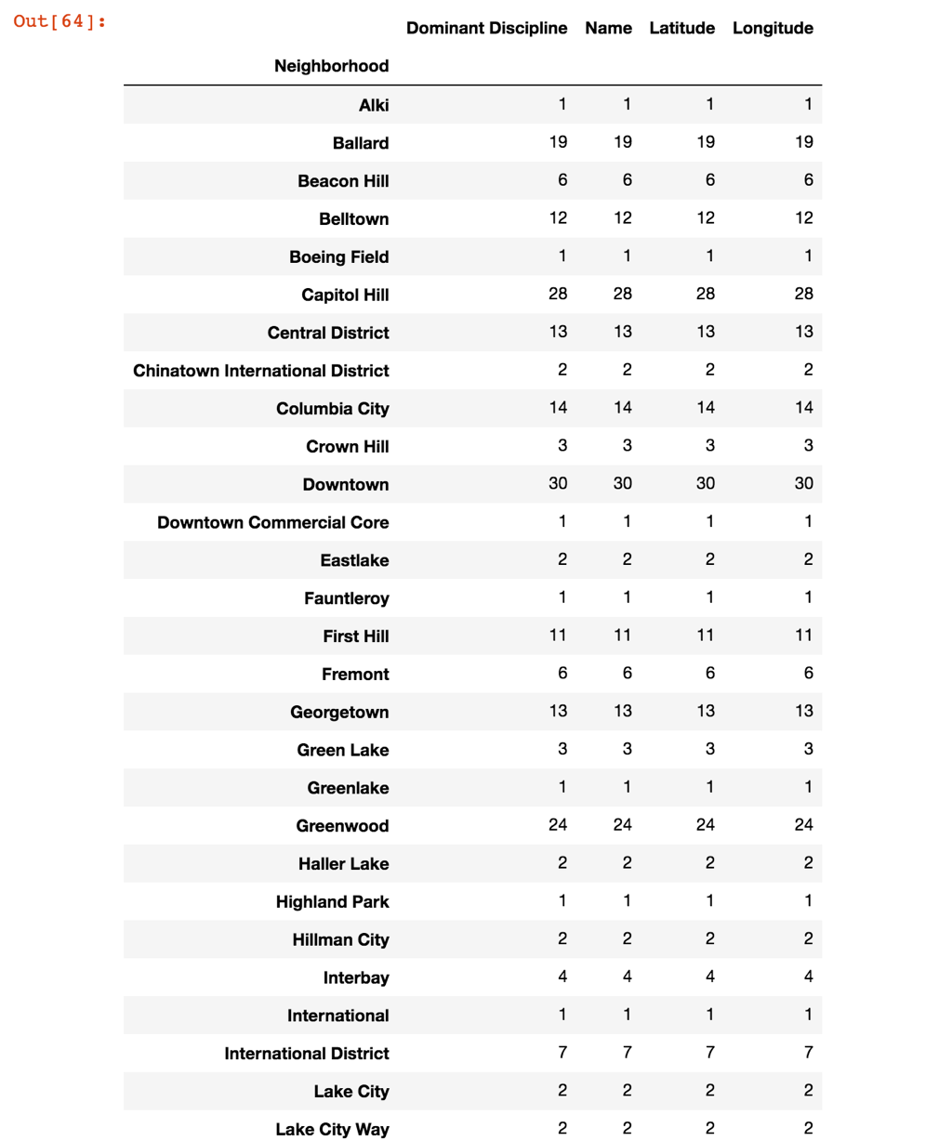

Top Neighborhood Cultural Space Inventory Counts:

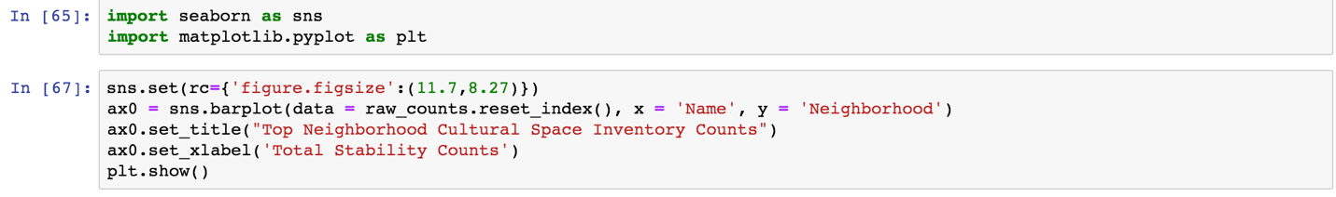

Results & Visualization:

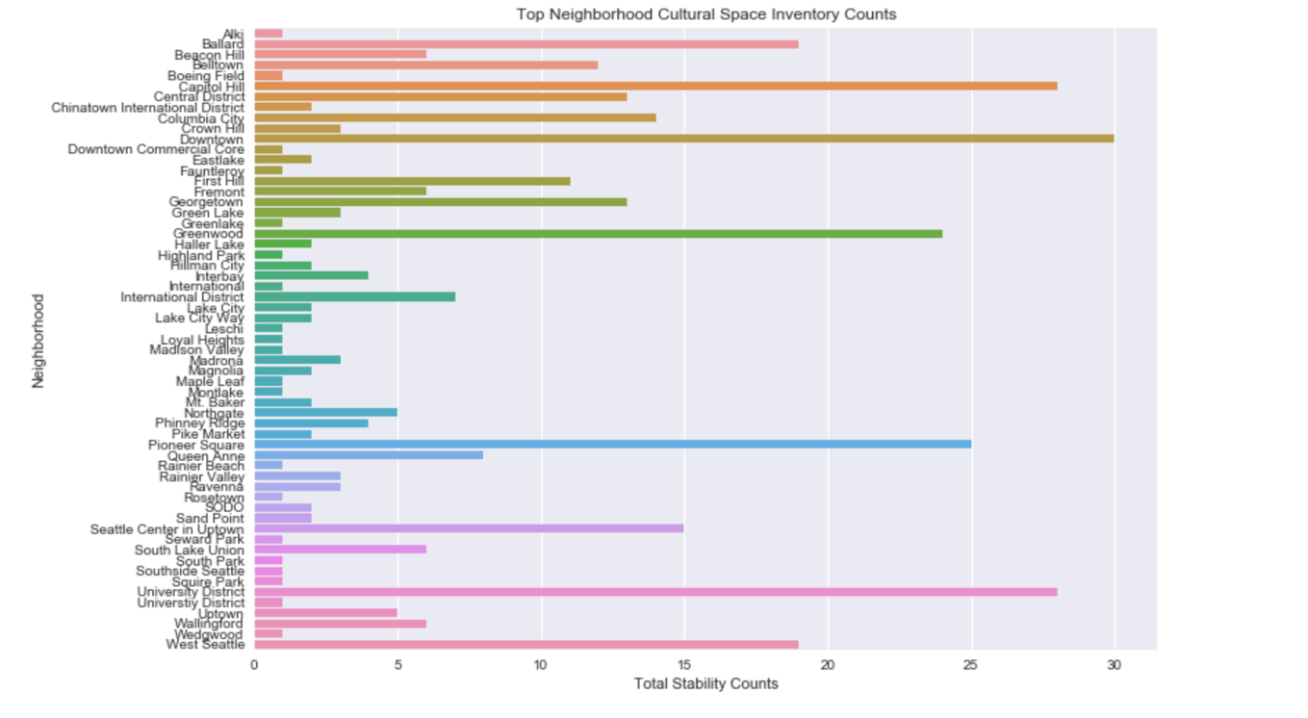

Top 10 most common Cultural Space Inventory type counts:

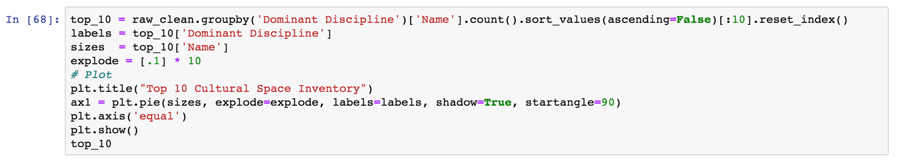

Results & Visualization:

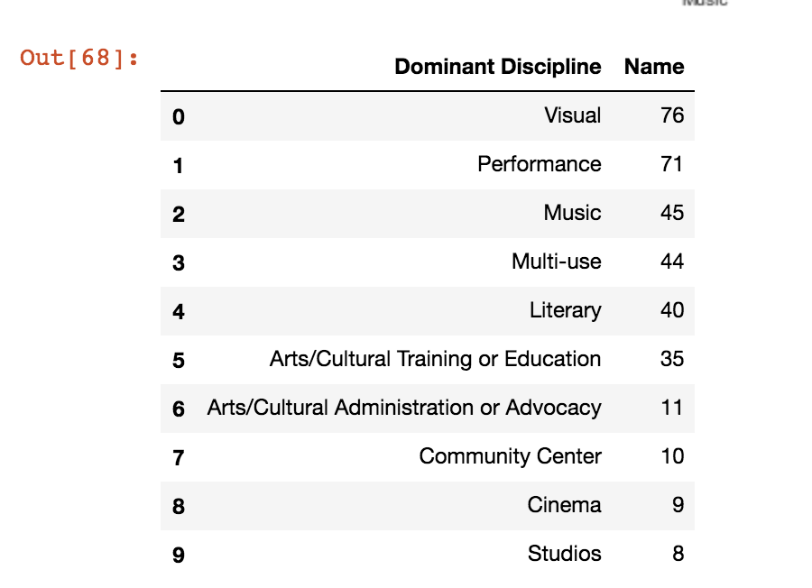

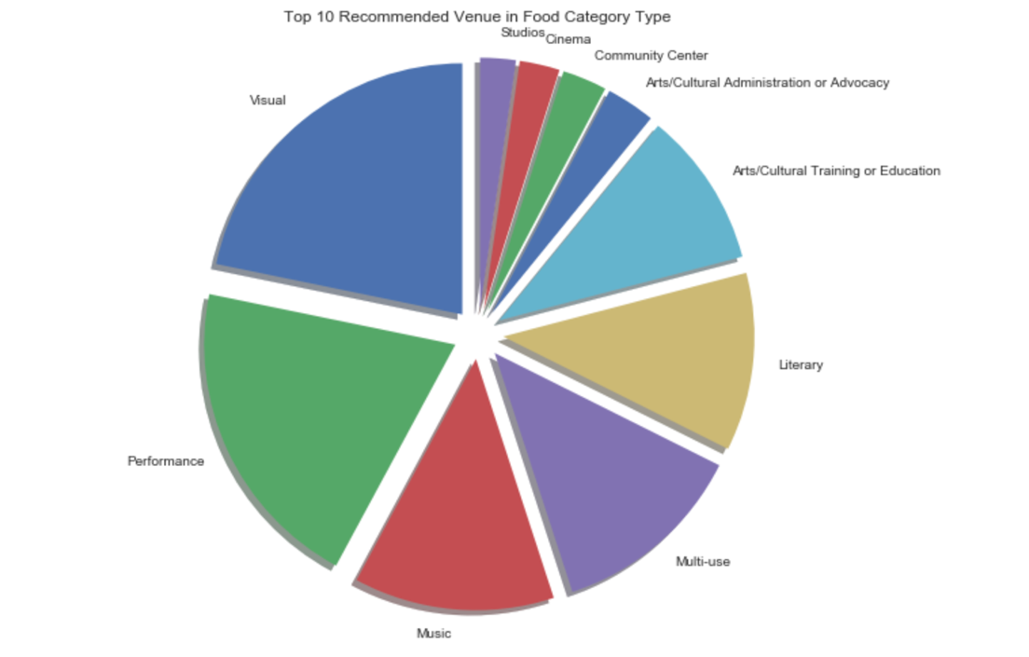

Coordinate data and render map with folium:

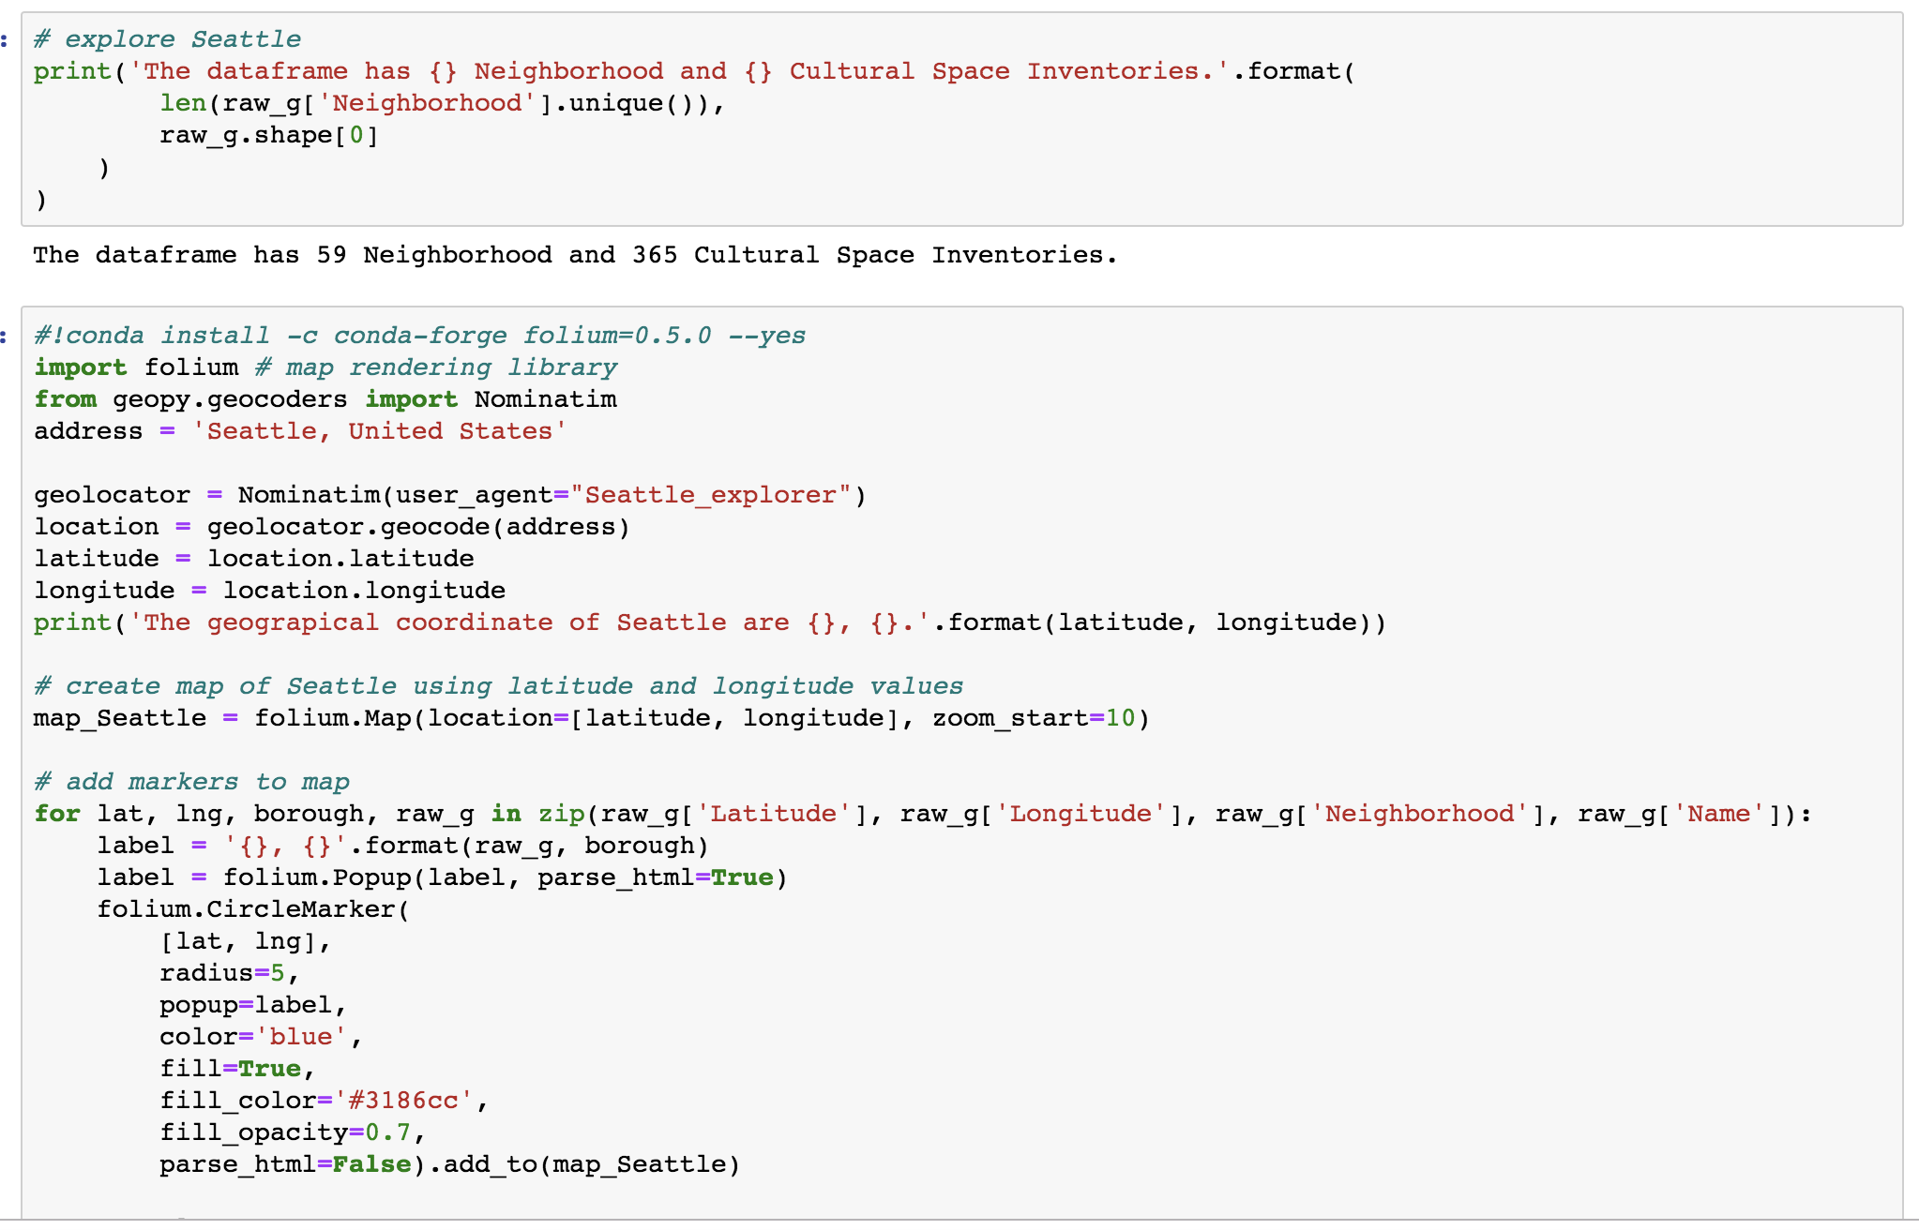

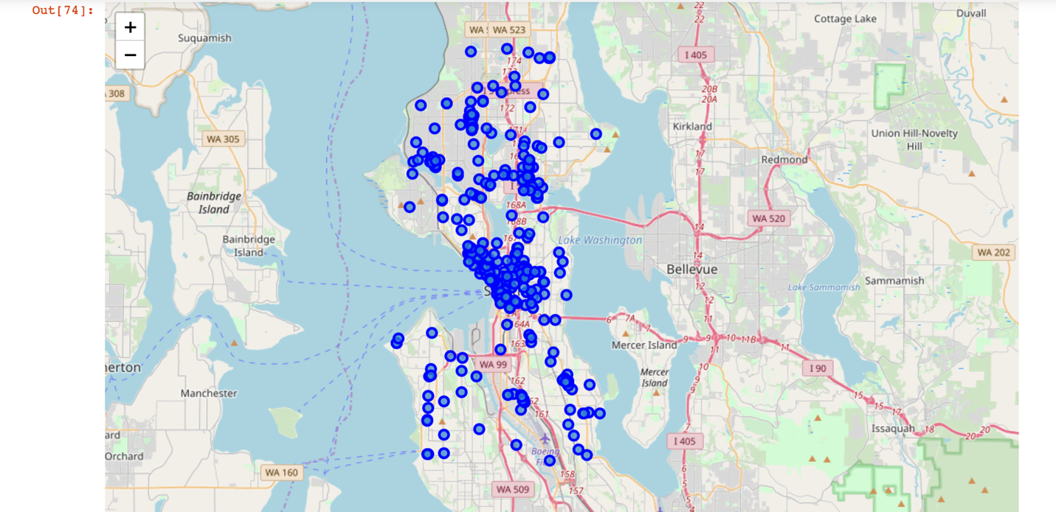

Conclusion:

Recommendation for Siyuan: Top three cultural neighborhood in Seattle are downtown, capitol hill and university district. Tope three cultural inventory are visual, performance and music. Seattle is a recommended city for artist.